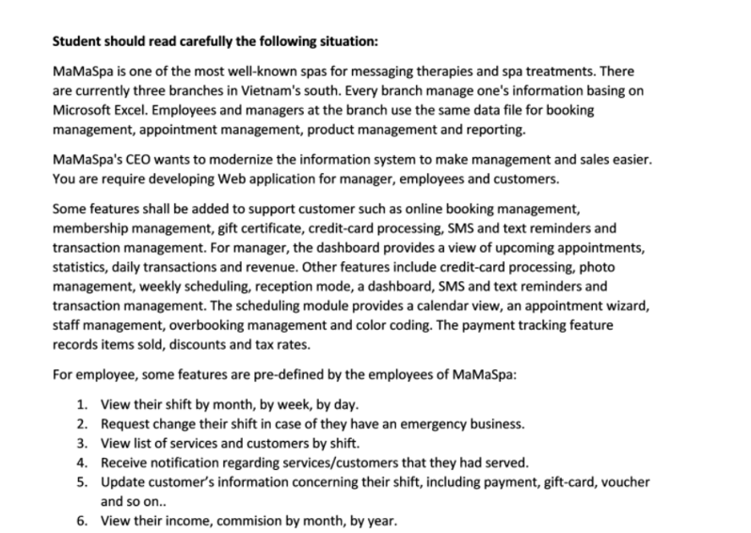

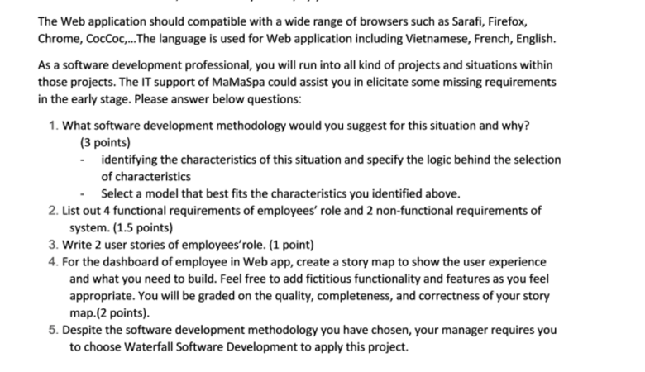

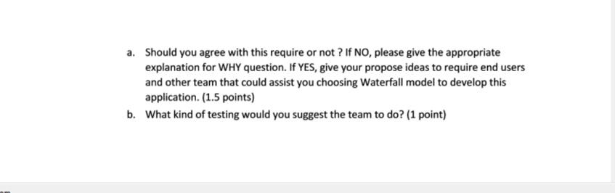

1. I suggest choosing Agile methodology, because:

* Reliability: requirements are quite clear by the college.
* Type of requirements: clearly divided from role:

+ For customer, online booking management, membership management, gift certificate, credit-card processing, SMS and text reminders and transaction management.

+ For manager, the dashboard provides a view of upcoming appointments, statistics, daily transactions and revenue



+ For employee, View their shift, Request change their shift, View list of services and customers by shift….

The benefit of Agile over waterfall is the ability to change dynamically to the customer's wants and needs:

* User involvement in the situation: large because assist you in elicitate some missing requirements in the early stage
* Team size: Small: a software development professional. So, Agile method is suitable for small groups.
* The software development methodology I suggest for this situation is AGILE

this is a new and big project, so it needs brain-storming, user surveys, changed many times; need to get feedback continuously after each time cycle to make adjustments. Also, to ensure the project is completed on time and within budget. The benefit of agile over waterfall is the ability to change dynamically to the customer's wants and needs. A focus on the features that are the highest value to the customer. So our new service could be stable, secure, and ease to use.

1. – List out 4 functional requirements of employees' role:

+ View their shift by month, by week, by day.

+ Request change their shift in case of they have an emergency business.

+ View list of services and customers by shift.

+ Receive notification regarding services/customers that they had served.

– List out 2 non-functional requirements of system role:

+ The Web application should compatible with a wide range of browsers such as Sarafi, Firefox,

Chrome. CocCoc....

+ The language is used for Web application including Vietnamese. French. English.

1. 2 user story of employee ‘s role:

* As a employee, I want to View list of services and customers by shift( , so …)
* As a employee, I want to Request change their shift in case of they have an emergency business.

5 No, you don’t want to choose Waterfall Software Development to apply this project.



* Because, I feel that the Agile model is the most appropriate approach in this situation due to the frequent supply of requirements. Since the requirements system is flexible and subject to change at any time, it is appropriate to deploy the system first rather than developing it in stages. The benefit of Agile over waterfall is the ability to change dynamically to the customer's wants and needs



5b, I suggest system testing for this project because In project, we have functional requirement and non-functional requirement is clear; It helps testing process is easier

